**Exercise - Introduction to HTML/CSS**

**How are inline and block elements different from each other?**

*<div>* tag is an example of block element, whereas *<span>* tag is an example of inline element.

**Block Elements** take up the full width of the parent element available when a new block element tag is encountered it adds a new line in the page.

**Inline Elements** take up the minimum width which is required. When a new inline element tag is encountered a new line is not added.

Screenshot(s)



**Explain the difference between visibility:hidden and display:none**

*visibility:hidden* loads the component and then hides it, also leaves the space in the page for that element.

*display:none* does not load the component and doesn’t leave space for that component.

Screenshot(s)

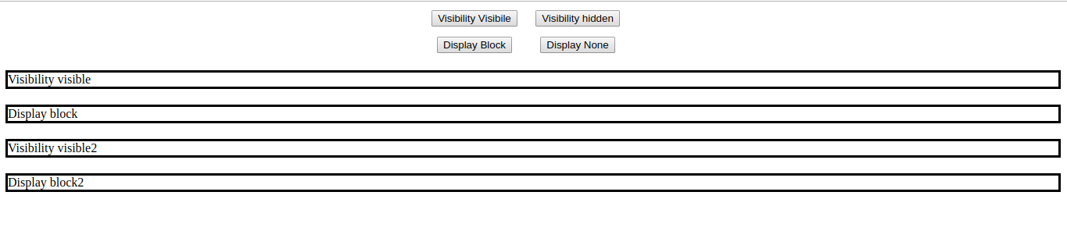

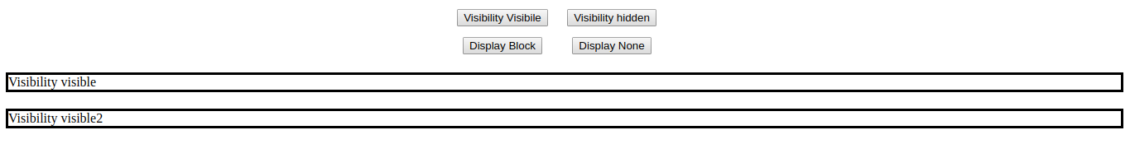

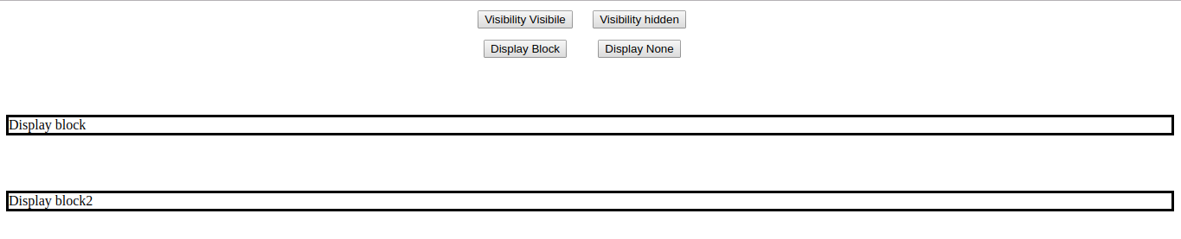

**Explain the clear and float properties.**

Float and clear properties are generally used one after the other.

Float is used for aligning of an HTML element other than text. Sometimes, float inserts unintended spacing, this is unneeded space is removed using Clear.

We use *float:left* to align or shift to left, *float: right* to align or shift to the right.

We use *clear:left* to remove the extra space on left, *clear:right* to remove the extra space of right and *clear: both* to remove extra space anywhere present.

**Explain difference between absolute, relative,fixed and static.**

We used these options with the styling *position*.

*position:absolute-* By absolute we mean that the HTML element with styling *position:absolute* will be positioned with respect to the any of its parent HTML element having styling as *position:relative*, if there is no such parent HTML element then the positions are given with respect to the body.

*position:fixed-* The element is positioned with respect to the browser window.

*position:static -* This is the default option of any HTML element. The element appears as mentioned in the document flow.

**Write the HTML code to create a table in which there are 4 columns( ID , Employee Name, Designation, Department) and at least 6 rows. Also do some styling to it.**

*CODE IN GITHUB*

Screenshot(s)



**Why do we use meta tags?**

Metadata is termed as data about data. In HTM *<meta>* tags are used to give data about the webpage.

*<meta>* tag is a kind of tag which is used to specify various properties of a web page. The content in the tag is not displayed on the web page but is machine parsable.

It also helps in SEO (Search Engine Optimization), we mention the keywords in the tag which helps search engine to search for the specific keywords. This tag is also used for responsiveness of the webpage.

**Explain box model.**

Box Model is a standard set for every HTML element. We have a few components of box model as-

* Component - This is the main HTML component.
* Padding - This is the margin inside the border. It is a blank space which is not visible.
* Border - This is the visible area after padding enclosing the HTML element.
* Margin - This is blank space outside the border and this is also not visible like padding.

Screenshot(s)

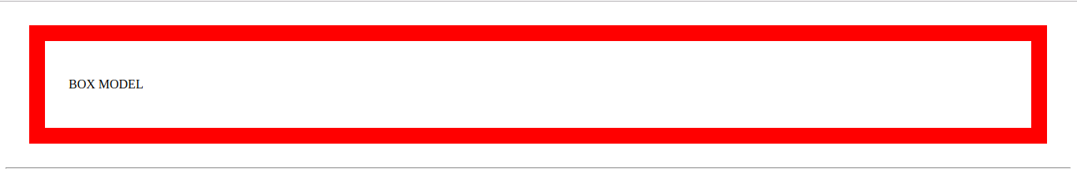

**What are the different types of CSS Selectors?**

In CSS, we have 3 types for Selectors.

* element - This means we are defining a style for all HTML tags of name *element*.
* .element - This means we are defining a style for all HTML elements with class as *element*.
* #element - This means we are defining a style for the HTML element with having id as *element*.

**Define Doctype.**

A document type declaration, or DOCTYPE, is an instruction that associates a particular SGML or XML document (for example, a webpage) with a document type definition (DTD) (for example, the formal definition of a particular version of HTML1.0 - HTML 4.0).

**Explain 5 HTML5 semantic tags.**

These tags newly introduced in HTML 5, mainly to increase the readability of the code.

* *<aside>* - This tag is used to make some content in the HTML to be aside and separated from rest of the content.
* *<footer>* - This tag is used to mark the footer of a page.
* *<header>* - This tag is used to mark the header of a page.
* *<section>* - This tag is a replacement of *<div>* in the sense that, this tag is used to denote the end and start of a particular section.

**Create HTML for web-page.jpg (check resources, highest weightage for answers)**

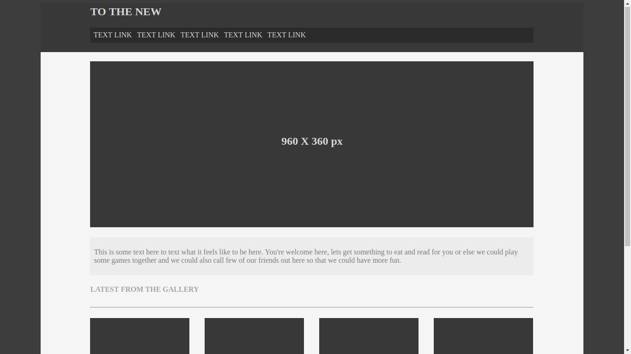



**Create HTML for form.png (check resources, highest weightage for answers)**

